**How to Use Microsoft Immersive Reader to Translate**

1. Download MS office online: <https://www.microsoft.com/en-us/microsoft-365/free-office-online-for-the-web>
2. Open a Word Doc and go to VIEW-Immersive Reader

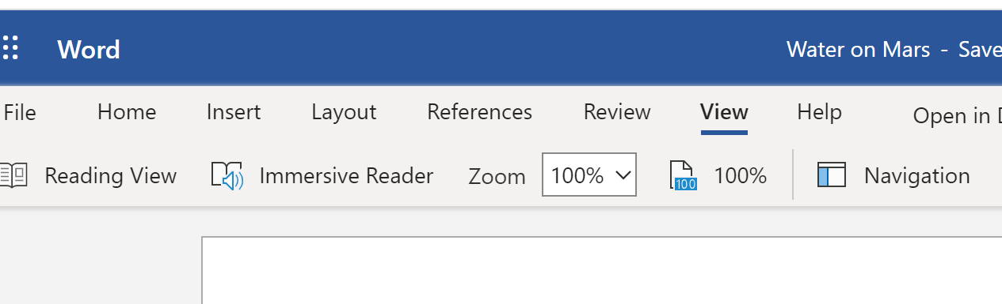

1. Click on the Immersive Reader and it will open the document in a new screen. Now you will see a menu of help from the right side of the screen. Click on the picture of the book.
2. Click on the box below “translate” and choose Spanish (Latin America).
3. Click on the  to use Picture Dictionary, By Word, or Document.

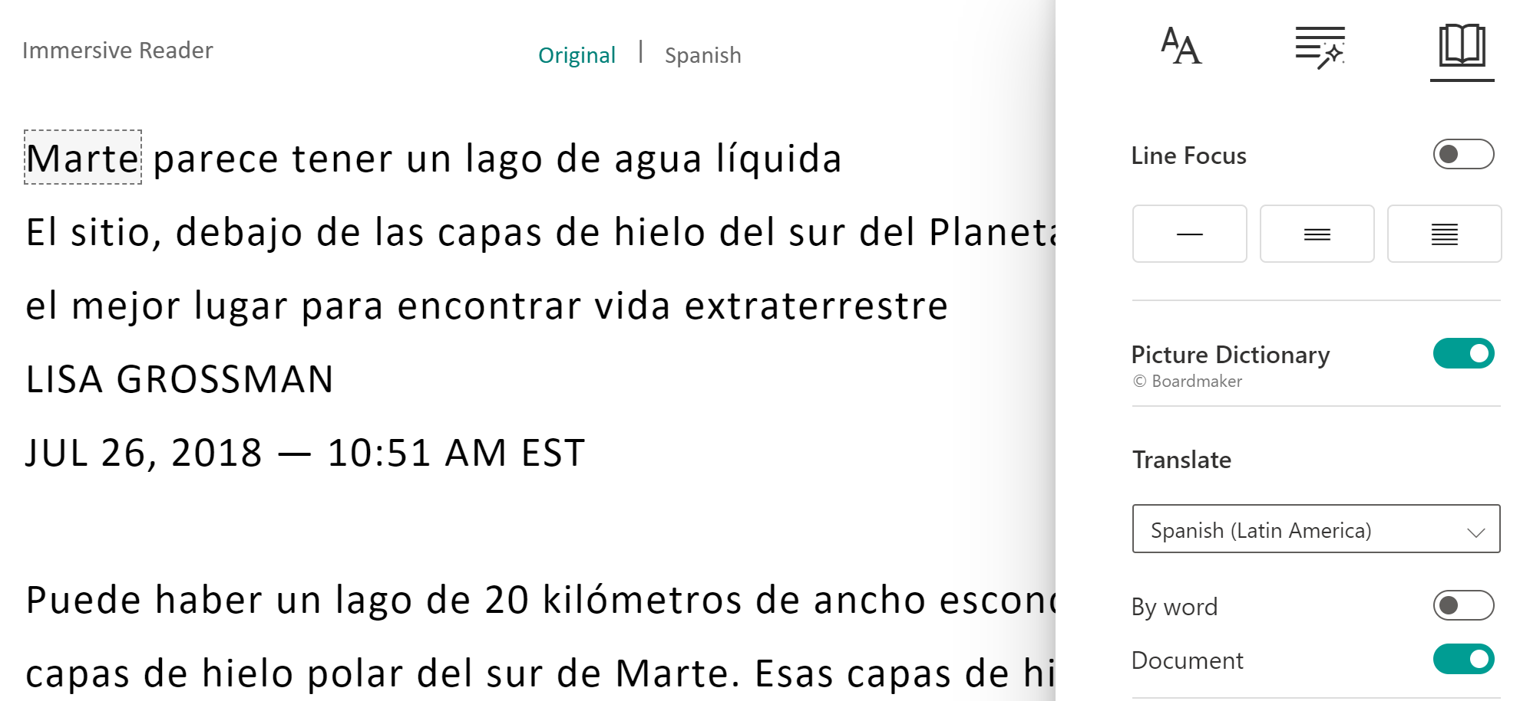

1. Finally, at the bottom of the screen you will click the mic button  to have it read to you. You choose male or female voice and change the speed!